**CRUDE OIL PRICE PREDICTION**

**A PROJECT REPORT**

**TEAM ID : PNT2022TMID25106**

**TEAM MEMBERS : 1 . KOWSALYA P (TEAM LEADER)**

**2 . SHALINI S**

**3 . SOMALAKSHMI S**

**4 . SOWMIYA K**

**BRANCH OF STUDY: B.TECH INFORMATION TECHNOLOGY**

**DMI COLLEGE OF ENGINEERING**

**ANNA UNIVERSITY: CHENNAI 600025**

Certified that this project report "CRUDE OIL PRICE PREDICTION” is the bonafide work of “KOWSALYA P ,SHALINI S ,SOMALAKSHMI S, SOWMIYA K ” who carried out the project work under my supervision.

SIGNATURE OF THE HOD SIGNATURE OF THE MENTOR

DR. MUTHUKUMAR Mrs. MARY DAIYANA

DMI college of engineering

Information technology

Palanchur . Nazrethpet post. Chennai 600123

# TABLE OF CONTENTS

**S.NO TITLE PG.NO**

# 1 INTRODUCTION

1.1 Project Overview

1.2 Purpose

# 2 LITERATURE SURVEY

2.1 Existing problem

2.2 References

2.3 Problem Statement Definition

**3 IDEATION & PROPOSED SOLUTION**

3.1 Empathy Map Canvas

3.2 Ideation & Brainstorming

3.3 Proposed Solution

3.4 Problem Solution fit

**4 REQUIREMENT ANALYSIS**

4.4 Functional requiremen

4.5 Non-Functional requirements

**5 PROJECT DESIGN**

5.1 Data Flow Diagrams

5.2 Solution & Technical Architecture

# 5.3 User Stories

# 6 PROJECT PLANNING & SCHEDULING

# 6.1 Sprint Planning & Estimation

# 6.2 Sprint Delivery Schedule

6.3 Reports from JIRA

**7 CODING & SOLUTIONING**

7.1 Feature 1

7.2 Feature 2

7.3 Database Schema (if Applicable)

**8 TESTING**

8.1 Test Cases

8.2 User Acceptance Testing

**9** **RESULTS**

9.1 Performance Metrics

**10 ADVANTAGES & DISADVANTAGES**

**11 CONCLUSION**

# 12 FUTURE SCOPE

**13 APPENDIX**

13.1 Source Code

13.2 GitHub & Project Demo Link

**1. INTRODUCTION**

**1.1PROJECT OVERVIEW**

Crude oil is the world's most leading fuel. The main advantages of crudeoil are it has high density, it is easily available. Oil is used in almost all the industries. Oil is a Constant Power Source. Oil energy is very reliable whencompared to other sources such as solar and wind energy. Some machine learningmodels fit the data set efficiently depending upon the type of data points provided. The main aim of this project is to find the different models that efficientlyfit the data points and predict the price of fuel with the help of machine learningmodels. This project works on comparing the different supervised learning models andbrings a conclusion based on the efficiency. We have used 3 supervised learningmodels namely, Random Forest Regression, Linear Regression and DecisionTreeRegression to know which gives the best in terms of accuracy and performance. These algorithms give a numeric value as output. So we can compare the output ofthese models with the actual models. Now-a-days the oil price has been increasing in leaps and bounds due to certain reasons like inflation throughout the world. Hence these are derivedor extracted from petroleum . The sources of crude oil for India come fromneighboring countries such as Dubai and Saudi-Arabia. To predict the values of petroleum like petroleum and Diesel within the future, we've decided to usetheMachine Learning algorithms and apply ensemble learning. Ensemble learning is a technique where we use different algorithms or single algorithms many times. In this way we can compare different algorithms and find the best one for our problem statement.

Crude oil has an essential role in the world, as this is one of the major products worldwide and thus includes global measurements. The origin of crudeoil prediction errors involves composite supply-demand structures. Crude oil volatility has a critical effect on economic factors which includes economicincrease of the country, unemployment, exchange rate that moreover depends oncrude oil export and import. In current days machine learning techniques canbeimplemented in various applications. Machine learning gives powerful computational tools and algorithms that are capable of learning itself andpredict data with long short-term memory. This paper contains LSTM based recurrent neural networks for the matterof crude oil price prediction. Recurrent neural networks (RNN) identifies tobethemost powerful and impact models for processing time-series based sequential data. LSTM variants can be used for other task as well other than prediction suchasspeech, handwriting and polyphonic modeling. The hyper parameters of variants

**2.LITERATURE SURVEY**

**2.1 EXISTING PROBLEM Survey 1:**

Jiayu Yi And Yuxiang Cheng (2019) "Multi-Scale Volatility and External Event Analysis of Crude Oil PricePrediction". crude oil price fluctuations and analyze the impacts of external events, thispaper first employs the CEEMD method to decompose the crude oil historical prices into different components and extracts a market fluctuation, a shockfromextreme events, and a long-term trend. And we find that when determiningthecrude oil prices, the shock from extreme events has become the most important factor. Then we combine the ICSS test with the Chow test to get the structural breaks and analyze extreme event impacts. Finally, considering the interactionbetween external event impacts and crude oil prices,we establish the models basedon VAR, SVM, and structural breaks to predict the crude oil prices, findingthat theCEEMD- VAR-SVM model with structural breaks performs best compared to other models we established.

**Survey 2:**

**Lu-Xi Liu AND Ming -Fang Li (2020)**

**"Google Index-Driven Oil Price Value-at-Risk Forecasting: A Decomposition**

**Ensemble Approach"**

The oil price is in fl-fluctuations not only by the fundamentals of supply and demand but also by unpredictable political conflicts, climate emergencies, and investor intentions, which cause enormous short term fl fluctuations in the oil price. The proposition of the Google index-driven decomposition ensemble model to forecast crude oil price risk uses big data technology and a time series decomposition method. First, by constructing an index of investor attention for the market and emergencies combined with a bi variate empirical mode decomposition, we analyze the impact of investor attention on oil price fl- fluctuations. Second,we establish a vector auto regression model, and the impulse responses define the impact of emergencies on the crude oil price. Finally, with the help of machine learning and historical simulation methods, the risk of crude oil price shocks from unexpected events is predicted. Empirical research demonstrates that concerns related to the oil market and emergencies that appear in Google search data are

closely related to changes in oil prices. Based on the Google index, our model’s prediction of crude oil prices is more accurate than other models, and the prediction of value-at-risk is closer to the theoretical value than the historical simulation with the ARMA forecasts method.

**Survey 3:**

**Azubuike H . Amadi , Orisa F. Ebube ,Silas I . Aire (2020)**

**“Effects of Covid-19 on Crude Oil Price and Future Forecast Using a Model**

**Application and Machine Learning”**

Oil Price has been a benchmark governing the trade of oil and gas globally. It is fixed by producing countries or countries in a consortium through organizations such as Organization of the Petroleum Exporting Countries (OPEC) or a particular mix of crude oil such as the West Texas Intermediate (WTI) or Brent. The spot price and future prices of crude oil is basically determined by demand and supply, however, some external factors can have great influence on oil price. This research work will be emphasizing on the direct and indirect effects of the COVID-19 pandemic as an external factor other than demand and supply on the benchmarks of oil pricing between 2000 and 2020. Having analyzed the various oil price fluctuation which have caused by several factors over the years, this research went further to identify those significant factors, weigh them and input them into a model that will generate simulated oil prices of past, present and future benchmarks with relation to demand, supply, production cost and other external factors. This model was also validated using machine learning algorithms and real data of previous yearly average oil price noting the reasons for each spot price. Significant recommendations were made on the use of this model for fixing oil price benchmarks as variables to each benchmark are numerous.

**Survey 4:**

**Hongli Niu And Yazhi Zhao (2021)**

**"Crude oil prices and volatility prediction by a hybrid model based on kernel**

**extreme learning machine"**

In view of the important position of crude oil in the national economy and its contribution to various economic sectors, crude oil price and volatility prediction have become an increasingly hot issue that is concerned by practitioners and researchers. In this paper, a new hybrid forecasting model based on variation al

mode decomposition (VMD) and kernel extreme learning machine (KELM) is proposed to forecast the daily prices and 7-day volatility of Brent and WTI crude oil. The KELM has the advantage of less time consuming and lower parameter- sensitivity, thus showing fine prediction ability. The effectiveness of VMD- KELM model is verified by a comparative study with other hybrid models and their single models. Except various commonly used evaluation criteria, a recently-developed multi-scale composite complexity synchronization (MCCS) statistic is also utilized to evaluate the synchrony degree between the predictive and the actual values. The empirical results verify that 1) KELM model holds better performance than ELM and BP in crude oil and volatility forecasting; 2) VMD-based model out performs the EEMD-based model; 3) The developed VMD-KELM model exhibits great superiority compared with other popular models not only for crude oil price, but also for volatility prediction.

**Survey 5:**

**Xinran Gao,Junwei Wang And Liping Yang (2022)**

**"An Explainable Machine Learning Framework for Forecasting Crude Oil**

**Price during the COVID-19 Pandemic "**

Financial institutions, investors, central banks and relevant corporations need an efficient and reliable forecasting approach for determining the future of crude oil price in an effort to reach optimal decisions under market volatility. This paper presents an innovative research framework for precisely predicting crude oil price movements and interpreting the predictions. First, it compares six advanced machine learning (ML) models, including two state-of-the-art methods: extreme gradient boosting (XGB) and the light gradient boosting machine (LGBM). Second, it selects novel data, including user search big data, digital currencies and data on the COVID-19 epidemic. The empirical results suggest that LGBM outperforms other alternative ML models. Finally, it proposes an interpretable framework forfacilitating decision making to interpret the prediction results of complex ML models and for verifying the importance of various features affecting crude oil price. The results of this paper provide practical guidance for participants in crude oil market.

**Survey 6:**

**M.Rajeswari , S. Ramya , A ArunPrasath (2022)**

**"OIL PRICE PREDICTION USING MACHINE LEARNING MODEL".**

Machine Learning allows programming applications to be more precise in predicting outcomes without having to explicitly customize it to try to do it. Oil plays an important part in the energy consumption of the world. The sharp rise in oil prices is shaking financial stocks globally. Because of non-linear factors, old statistical models are not suitable for accurately mpts us to mandate as a commitment to give a simple consent to the subsequent representation of oil price data and its related Index .

**2.2 REFERENCES**

1. An, Jaehyung. "Oil price predictors: Machine learning approach." 670216917 (2019).

2. Haykin, S. (1999). Neural Networks: A Comprehensive Foundation, 2nd edition, Prentice Hall, 842

3. Gupta, Nalini, and Shobhit Nigam. "Crude oil price prediction using artificial neural network." Procedia Computer Science170 (2020): 642-647.

4. Nandan Pandey. “Crude Oil Stock Price.” Kaggle, 22 July 2020, www.kaggle.com/awadhi123/crude-oilstock-price.

5. Coupland, Christine, and Andrew D. Brown. "Constructing

organizational identities on the web: A case study of Royal Dutch/Shell." Journal of management studies 41.8 (2004): 1325-1347

6. Kaufmann, R. K., & Ullman, B. (2009). Oil prices, speculation, and fundamentals: Interpreting causal relations among spot and futures prices. Energy Economics, 31(4), 550–558.

7. Shobhit Nigam. "Chapter 84 Single Multiplicative Neuron Model in Reinforcement Learning" , Springer Science and Business Media LLC, 20192.3

**PROBLEM** **STATEMENT DEFINITION**

Oil demand is inelastic, therefore the rise in price is good news for producers because they will see an increase in their revenue. Oil importers, however, will experience increased costs of purchasing oil. Because oil is the largest traded commodity, the effects are quite significant. A rising oil price can even shift economic/political power from oil importers to oil exporters. The crude oil price movements are subject to diverse influencing factors. Crude oil prices react to many variables, including supply and demand prospects and the perceived risk of market disruptions. Economic growth can drive up the demand for crude oil, while slowdowns tend to lower demand and prices.Crude oil prices react to many variables, including supply and demand prospects and the perceived risk of marke disruptions. Economic growth can drive up the demand for rude oil, while slowdowns tend to lower demand prices.High oil prices can drive job creation and investment as it becomes economically viable for oil companies to exploit higher-cost shale oil deposits. However, high oil prices also hit businesses and consumers with higher transportation and manufacturing costs.

Factors That Influence Pricing Of Oil And Gas

demand,Supply

Speculation, Demand for Oil.

Temporary Price Fluctuations.

Investing in Oil and Gas Drilling

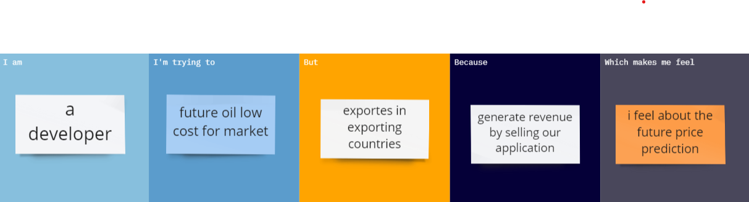

**3. IDEATION & PROPOSED SOLUTION**

**3.1 EMPATHY MAP CANVAS**

It’s easy to jump straight into value proposition design. That is the core of your business and where the revenue or exchange of value will come from. However, trying to provide value to a misunderstood customer is very risky business. Do you have your blinkers on? Try using this canvas before you design your value proposition to make sure your offer nails exactly what your customer wants, needs, or may pleasantly surprise them! Keep asking yourself “why would they care?”. What problem are you solving? What opportunity are you creating? In this empathy map what customer think and feels. this map shows the pain and gain of the customer and what do their hear about the problem. this is the easy way to understand the problem statement.

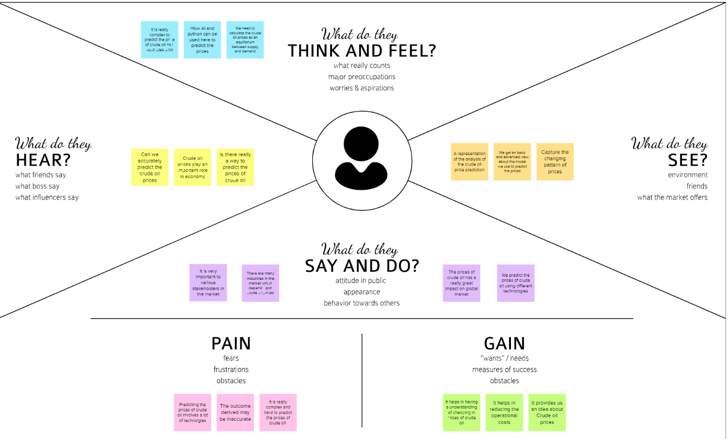

**3.2 IDEATION & BRAINSTORMING**

Brainstorming is **a method of generating ideas and sharing knowledge to solve a particular commercial or technical problem, in which participants are encouraged to think without interruption**. Brainstorming is a group activity where each participant shares their ideas as soon as they come to mind

**3.3 PROPOSED SOLUTION**

Prediction of future crude oil price considered a significant challenge to the extremely complex,and dynamic nature of the market and stakeholders perception. Generate Revenue by Selling our application.The crude oil price movements are subject to diverse influencing factors. Includes on applying neural networks to predict the crude oil price .we are using the previous history of crude oil prices to predict future crude oil so,we would implement and improve to accuracy model. Our aim is to build an application of heart diseases prediction system

using Flask and deployed on Heroku. A csv file is given as input. aAfter the successful completion of operation the result is predicted and displayed.

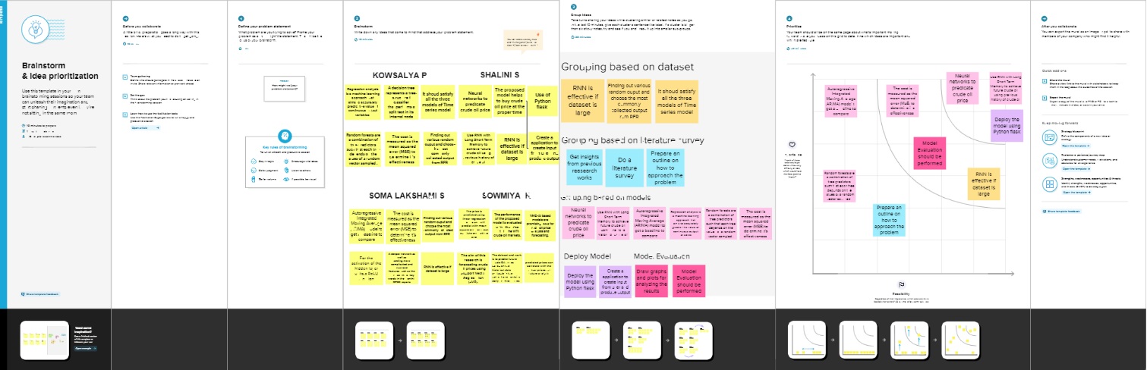

**3.4 PROBLEM SOLUTION FIT**

The Problem-Solution Fit simply means that you have found a problem with your customer and that the solution you have realized for it actually solves the customer’s problem. After having identified the target customer segment, it’s time to **investigate their needs**. One of the cheapest, fastest and most informative things to do at this stage is to meet with customers through **customer discovery interviews** (more about customer discovery interviews here and here) until we keep hearing the same things from customers. Meeting with a customer is an invaluable source of insights, much more valuable than a survey.Besides, as entrepreneurs, our job is to meet and pitch to

customers all the time, we’d be better off to start earlier rather than later.

**4. REQUIREMENT ANALYSIS**

**A functional requirement defines a system or its component. A non-functional requirement defines the quality attribute of a software system**. It specifies “What should the software system do?” It places constraints on “How should the software system fulfill the functional requirements?

**4.1 FUNCTIONAL REQUIREMENT**

|  |  |  |
| --- | --- | --- |
| Fr no | Functional requriement(epic) | sub requriement (story /sub-task) |
| Fr-1 | User application | User diect open with google play store app  user can download the crude oil price |
| Fr-2 | User product available | User using the application there are so many products in crude oil price app  user updates the energy and oil price instant the application |
| Fr-3 | User additional features | User can read latest news and view oil price charts  user view major energy quotes  user can using multiple color themes |
| Fr-4 | User exception | User can exchange rates and currancy converter |

**4.2 NON-FUNCTIONAL REQUIREMENT**

NON FUNCTIONAL REQUIREMENTS

Following are the non-functional requirements of the proposed solution

|  |  |  |
| --- | --- | --- |
| FR NO | NON - FUNCTIONAL REQURIEMENT | DESCRIPTION |
| NFR-1 | Usability | Used to improve to the accuracy of crude oil price prediction |
| NFR-2 | Security | In the rising oil price can even shift eonomical/political power from oil imports to oil exporters communication will be secured |
| NFR-3 | Reliability | Reliability of the pointing towards high -risk components |
| NFR-4 | Performance | Performance of the projects is to improve to the accuracy of oil price prediction |
| NFR-5 | Availability | The availability solution is more benefit for and the imports and exporters in the crude oil price prediction |
| NFR-6 | Scalability | The scalability are 90%-95% |

**5.PROJECT DESIGN**

**5.1 DATA FLOW DIAGRAM**

A data flow diagram (DFD) is **a graphical or visual representation using a standardized set of symbols and notations to describe a business's operations through data movement**

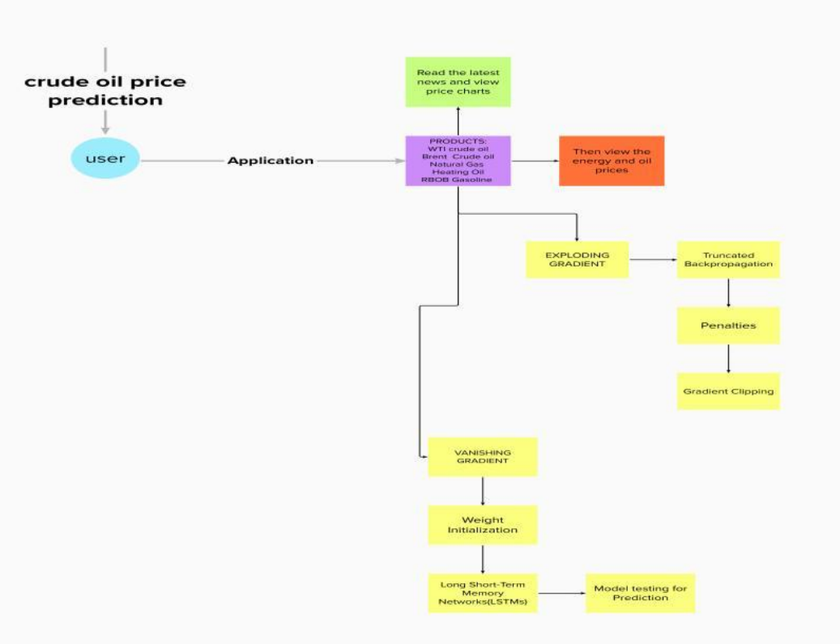

In this flow diagram we are showing that the crude oil price prediction

**5.2 SOLUTION AND TECHNICAL ARCHITECTURE**

A solution architecture (SA) is **an architectural description of a specification solution**. SA combine guidance from different enterprise architecture viewpoints (business, information and technical), as well as from the enterprise solution architecture (ESA)

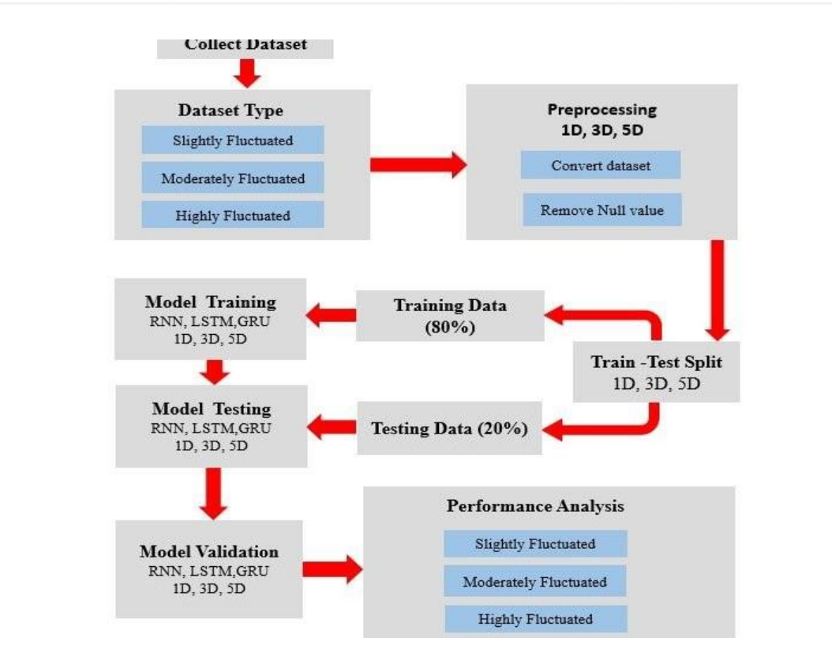

**5.3 User Stories**

**user stories**

use the below template to list all the stories for the product

|  |  |  |  |  |  |  |
| --- | --- | --- | --- | --- | --- | --- |
| **User type** | **Functional requriment** | **User story number** | **User story /task** | **Acceptance criteria** | **Priority** | **Releases** |
| **Customer**  **(mobile user)** | **Application** | **Usn-1** | **As a user direct open with google play store app user can download the crude oil price** | **I can access own decisions** | **high** | **sprint-1** |
|  | **Available products** | **Usn-2** | **As a user the application there are so many products in crude oil price app**  **user update the energy and oil price instant the application** | **I can receive the data once click then confrim** | **high** | **sprint-2** |
|  | **Additional features** | **Usn-3** | **As a user can read latest news and view oil price charts**  **user view major energy quotes**  **user can using a multiple color themes** | **I can view then read the price prediction** | **high** | **sprint-1** |
|  | **Expectations** | **Usn-4** | **User can exchange rates and currency converter** | **I can expect** | **medium** | **sprint-1** |
|  | **login** | **Usn-5** | **As a user ,login directly then no email,username,**  **password** |  |  | **sprint-1** |
|  |  |  |  |  |  |  |
| **Customer**  **(web user)** |  |  | **As a user I can view the crude oil price** | **I can view the price directly** | **high** | **sprint-1** |
| **Customer care executive** |  |  | **As a user I executive the given price history** | **I can accept the terms** | **medium** | **sprint-1** |

**6.PROJECT PLANNING & SCHEDULING**

**6.1 Sprint Planning & Estimation**

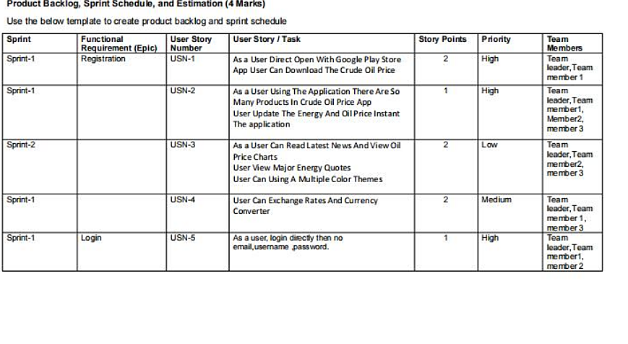

**6.2 SPRINT**

DELIVERY&SCHEDULE

|  |  |  |
| --- | --- | --- |
| TITLE | DESCRIPTION | DATE |
| Literature survey& information gathering | Literature survey on the selected project & gathering information by referring the,technical papers,research publications etc. | 28 SEPTEMBER 2022 |
| prepare empathy map | prepare empathy Map Canvas to capture the user pains&gains,the prepare list of problem statements | 10 OCTOBER 2022 |
| Ideation | list the by organizing the brainstorming session and prioritize the top 3 ideas based on the feasibility | 30 SEPTEMBER 2022 |
| proposed solution | prepare the proposed solution document,which includes the novelty,feasibility of idea,business model,social impact, | 5 OCTOBER 2022 |
| problem solution fit | prepare problem-solution fitdocument | 25 SEPTEMBER 2022 |
| Solution architecture | prepare solution architecture document. | 11 OCTOBER 2022 |
| Customer journey | prepare the customer journey maps to understand the user interaction and experience with the application (entry to exit) | 9 OCTOBER 2022 |
| Functional requriement | prepare the function requriment document | 20 OCTOBER2022 |
| Data flow diagrams | draw the data flow diagrams and submit for review | 23 OCTOBER 2022 |
| Technology architecture | prepare the technology architecture diagram | 26 OCTOBER 2022 |
| Prepare milestone and activity list | prepare the milestone and activity list of the project | 26 OCTOBER 2022 |
| Project development -delivery of sprint -1,2,3&4 | develop & submit the deveoped code by testing it | 12 NOVEMBER 2022 |

**6.3 REPORT FROM JIRA**

A Burn down chart **shows the amount of work that has been completed in an epic or sprint, and the total work remaining**. Burn down charts are used to predict your team's likelihood of completing their work in the time available.

**Burn down chart:**

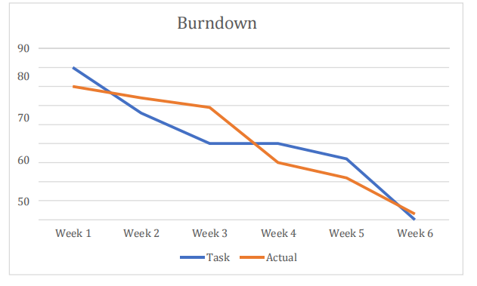

**7. CODING & SOLUTIONING**

**7.1 FEATURE 1**

<!DOCTYPE html>

<html lang="en">

<head>

<meta name="viewport" content="width=device-width, initial-scale=1.0">

<title>Home page</title>

<link rel="stylesheet" href="style.css">

</head>

<body>

<div class="main">

<div class="navbar">

<div class="icon">

<h2 class="logo">CRUDE OIL</h2>

</div>

<div class="menu">

<ul>

<li><a href="#">HOME</a></li>

<li><a href="#">ABOUT</a></li>

<li><a href="#">SERVICE</a></li>

<li><a href="#">CONTACT</a></li>

</ul>

</div>

<div class="search">

<input class="srch" type="search" name="" placeholder="Type To text"

<a href="#"> <button class="btn">Search</button></a>

</div>

</div>

<div class="content">

<p class="par"> Crude oil means a mixture of hydrocarbons that exists in

liquid phase in<br>

natural underground reservoirs and remains liquid <br>at atmospheric

pressure

after passing through <br>surface separating facilities.</p>

<button class="cn"><a href="register.html">JOIN US</a></button>

<div class="form">

<h2>Login Here</h2>

<input type="email" name="email" placeholder="Enter Email Here">

<input type="password" name="" placeholder="Enter Password

Here">

<button class="btnn"><a href="#">Login</a></button>

<p class="link">Don't have an account<br>

<a href="#">Sign up </a> here</a></p>

<p class="liw">Log in with</p>

<div class="icons">

<a href="#"><ion-icon name="logo-facebook"></ion-icon></a>

<a href="#"><ion-icon name="logo-google"></ion-icon></a>

</div>

</div>

</div>

</div>

</div>

</div>

<script src="https://unpkg.com/ionicons@5.4.0/dist/ionicons.js"></script>

</body>

</html>

**7.2 FEATURE 2**

color:#ff7200

}*{

margin: 0;

padding: 0;

}

body{

background:url(cr.jpg);

background-position: center;

background-size: cover;

}

div.main{

width: 400px;

margin: 100px auto 0px auto ;

}

h2{

text-align: center;

padding: 20px;

font-family: Arial;

}

div.register{

background-color: rgba(0, 0, 0, 0.5);

width: 100%;

font-size: 20px;

border-radius: 10px;

border: 1px solid rgba(255, 255, 255, 0.3);

box-shadow: 2px 2px 15px

rgba(0,0,0,0.3);

form#register{

margin: 40px;

}

label{

font-family: Arial;

font-size: 18px;

}

input#name{

width: 300px;

border: 1px solid #ff7200;

border-radius: 3px;

outline: 0;

padding: 7px;

background-color: #000;

box-shadow: inset 1px 1px 5px

rgba(0, 0, 0, 0.3);}

input#submit{

width: 240px;

height: 40px;

background: #ff7200;

border: none;

margin-top: 30px;

font-family: Arial;

font-size: 18px;

font-weight: bold;

border-radius: 10px;

cursor: pointer;

color: #fff;

transition: 0.4s ease;

margin-bottom: 20px;

}

label,h2{

text-shadow: 1px 1px 5px rgba(0, 0, 0, 0.3);

}

span{

color: #000;

text-shadow: 1px 1px 5px rgba(0, 0, 0, 0.3);

}

font-size: 1.5vw; border-radius: 10px;

margin: 2px;

padding: 8px;

}

.form input{

width: 240px;

height: 35px;

background: transparent;

border-bottom: 1px solid #ff7200;

border-top: none;

border-right: none;

border-left: none;

color: #fff;

font-size: 15px;

letter-spacing: 1px;

margin-top: 30px;

font-family: sans-serif;

}

.form input:focus{

outline: none;

}

::placeholder{

color: #fff;

font-family: Arial;

}

.btnn{

width: 240px;

height: 40px;

background: #ff7200;

border: none;

margin-top: 30px;

font-size: 18px;

border-radius: 10px;

cursor: pointer;

color: #fff;

transition: 0.4s ease;

}

.btnn:hover{

background: #fff;

color: #ff7200;

}

.btnn a{

text-decoration: none;

color: #000;

font-weight: bold;

}

.form .link{

font-family: Arial, Helvetica, sans-serif;

font-size: 17px;

padding-top: 20px;

text-align: center;

}

.form .link a{

text-decoration: none;

color: #ff7200;

}

.liw{

padding-top: 15px;

padding-bottom: 10px;

text-align: center;

}

.icons a{

text-decoration: none;

color: #fff;

}

.icons ion-icon{

color: #fff;

font-size: 40px;

padding-left: 60px;

padding-top: 5px;

transition: 0.3s ease;

}

.icons ion-icon:hover{

color: #ff7200;

}

@media screen and (max-width:1200px) {

/*Normal Screen*/

.navbar{

width: 100%;

height: 100px;

}

ul{

margin-left: 30px;

}

ul li{

margin-left: 60px;

}

ul li a{

font-size: 1.6vw;

}.search{

margin-top: 3px;

margin-left: 290px;

}

.srch{

height: 40px;

width: 190px;

font-size: 14px;

}

.btn{

height:40px;

width: 80px;

}

.content{

width: 100%;

}

.content h1, .content span{

font-size: 4.5vw;

}

.content .par{

width: 90%;

}

.content .cn{

width: 13%;

height: 3.5vw;

font-size: 1.8vw;

}

.content a{

font-size: 1.6vw

}

}

@media screen and (max-width:1170px) {

/*Login-box*/

.main{

padding-left: 20px;

height: 180vh;

}

.form{

margin-left: -30px;

width: 250px;

height: 370px;

background: linear-gradient(to top, rgba(0,0,0,0.8)50%,rgba(0,0,0,0.8)50%);

position: absolute;

top: 420px;

**8. TESTING**

**8.1 TEST CASES**

A test case is nothing but **a series of step executed on a product, using a predefined set of input data, expected to produce a pre-defined set of outputs, in a given environment**. It describes “how” to implement those test cases. Test case specifications are useful as it enlists the specification details of the items. The purpose of testing is to discover errors . Testing is the process of trying to discover every conceivable fault or weakness in a work product . It provide a way to check the functionality of component , sub assemblies , assemblies and/or a finished product.It is the process of exercising software with the intent of ensuring that the software system meets its requirement and user expectation and does not fail in an unacceptable manner. There are various types of testing. Each test type addressing a specific testing requirement. The testing report are submitted in github.

**8.2 USER ACCEPTANCE TESTING**

User acceptance testing is a critical phase of any project and requires significant participant by the end user. It also ensure that the system meets the functional requirement.

1. Purpose of Document

The purpose of this document is to briefly explain the test coverage and open issues of the [Crude Oil] project at the time of the release to User Acceptance Testing (UAT).

2. Defect Analysis

This report shows the number of resolved or closed bugs at each severity level, and how they were resolved

|  |  |  |  |  |  |
| --- | --- | --- | --- | --- | --- |
| Resolution | Severity 1 | Severity 2 | Severity 3 | Severity 4 | Subtotal |
| By design | 10 | 4 | 3 | 2 | 19 |
| External | 1 | 0 | 2 | 0 | 3 |
| Fixed | 2 | 2 | 0 | 1 | 5 |
| Fixed | 11 | 2 | 4 | 20 | 37 |
| Not Reproduced | 0 | 0 | 1 | 0 | 1 |
| Skipped | 0 | 1 | 0 | 0 | 1 |
| Wont'Fix | 1 | 5 | 0 | 0 | 6 |
| Totals | 25 | 14 | 10 | 23 | 72 |

**1.TEST CASE ANALYSIS**

|  |  |  |  |  |
| --- | --- | --- | --- | --- |
| **Selection** | **Total case** | **Not tested** | **Fail** | **Pass** |
| Print Engine | 7 | 1 | 1 | 5 |
| Client Application | 51 | 0 | 1 | 50 |
| Security | 2 | 0 | 0 | 2 |
| Outsource shipping | 3 | 0 | 0 | 3 |
| Expertion Reporting | 9 | 0 | 0 | 9 |
| Final Report Output | 4 | 0 | 0 | 4 |
| Version | 2 | 0 | 0 | 2 |

**9.RESULT**

**9.1 PERFORMANCE MATRICES**

Project team shall fill the following information in model performance testing templates

|  |  |  |  |
| --- | --- | --- | --- |
| S.NO | PARAMETER | VALUES | SCREENSHOT |
| 1. | Metrix | REGERSSION MODEL:  MAE-,MSE-, RMSE-,R2 score  CLASSIFICATION MODEL:  confusion matrix-, Accuracy score-&classification report | RMSE for different models used in our projects  Liner Regression:19.3533662859143 |
| 2. | Tuned the model | Hyper parameter tunning-validation method. | Hyper parameter tuning  In the cse of over fitting, some inclusion of regularization and further hyper parameter tuning for the training process must be considerd. A good model should be based on a compromise between capturing the essential patterns in the data. |

**10. ADVANTAGE**

• The advantage of this model are high performance and accuracy rate.

• It is very flexible and high rates of success are achieved

• The application when implemented using random forests has more accuracy rate when compare to other algorithm. In this system, we achieve around 98%.

**11. CONCLUTION**

The main purpose of this paper is to develop a time series collection of regular observations on oil price datasets. Used to predict future value based on historical data. Non- linear trends are fitted using annual, weekly, and daily data. This white paper integrates machine learning models such as FB Prophet a to analyze, classify, and predict time series data.Historical data is presented using variables analyzed and calculated during the algorithm execution module, and each algorithm makes a series of oil price predictions using this setof values.

**12. FUTURE SCOPE**

The project's future potential is enormous. The project can be implemented with the real-time functionalities that are necessary. Because it is quite versatile in terms of expansion, the project can be upgraded in the near future as and when the need arises. The complete prediction value can be increased in a much better, accurate, and error-free mannerwith the proposed approach. The project can be enhanced withreal time data.

**12. APPENDIX**

**PYTHON**

Python is a computer programming language often used to **build websites and software, automate tasks, and conduct data analysis**. Python is a general purpose language, meaning it can be used to create a variety of different programs and isn't specialized for any specific poblems.

**SOURCE CODE**

**LOGIN**

h1 {

text-align: center;

color: floralwhite;

font-size: 50px;

font-family: cursive;

}

p {

font-family: cursive;

color: ghostwhite;

margin-right: 30px;

margin-left: 30px;

text-align: center;

font-size: 20px;

font-weight: bold;

}

body{

background: url(back2.jpg);

background-repeat: no-repeat;

background-size: 100% 275%;

}

.button {

display: inline-block;

border-radius: 4px;

background-color: black;

border: none;

color: #FFFFFF;

text-align: center;

font-size: 20px;

padding: 12px;

width: 100px;

transition: all 0.5s;

cursor: pointer;

margin: 5px;

}

a{

font-size: 20px;

font-family: cursive;

color: ghostwhite;

margin-right: 30px;

margin-left: 30px;

text-align: center;

font-size: 20px;

font-weight: bold;

}

**USER REGISTRATION**

<!DOCTYPE html>

<html>

<head>

<title>Registration Form</title>

<link rel="stylesheet"

href="register.css" type="text/css">

</head>

<body>

<div class="main">

<div class="register">

<h2>Register Here</h2>

<form id="register" method="post"><label>First Name : </label>

<br>

<input type="text" name="fname"

id="name" placeholder="Enter Your First Name">

<br><br>

<label>Last Name : </label>

<br>

<input type="text" name="lname"

id="name" placeholder="Enter Your last Name">

<br><br>

<label>Your Age : </label>

<br>

<input type="number" name="age"

id="name" placeholder="How Old Are You">

<br><br>

<label>Email : </label>

<br>

<input type="email" name="email"

id="name" placeholder="Enter Your Valid Email">

<br><br>

<label>Gender : </label>

<br>

<input type="radio" name="gender"

id="male">

<span id="male">Male</span>

<input type="radio" name="gender"

id="female">

<span id="female">Female</span>

<br><b

<input type="submit" value="Submit"

name="submit" id="submit">

</form>

</div>

</div>

</body>

</html

**BUILD CODE**

import numpy as np

from flask import Flask,render_template,request #flask is a application

#uesd to run/serve our application

#request is used to access the files which is uploaded by the user in

#our application

#render_template is used for rendering the html pages

from tensorflow.keras.models import load_model

app = Flask(__name__)#our flask app

model = load_model('crude_oil.h5',)#loading the model in the flask app

@app.route('/')

def home() :

return render_template("index.html")

@app.route('/about')

def home1() :

return render_template("index.html")

@app.route('/predict')

def home2() :

return render_template("web.html")

@app.route('/login',methods =['POST'])

def login() :

x_input=str(request.form['year'])

x_input=x_input.split(',')

print(x_input)

for i in range(0, len(x_input)):

x_input[i] = float(x_input[i])

print(x_input)

x_input=np.array(x_input).reshape(1,-1)

temp_input=list(x_input)

temp_input=temp_input[0].tolist()

lst_output=[]

n_steps=10

i=0

while(i<1):

if(len(temp_input)>10):

#print("temp_input",temp_input)

x_input=np.array(temp_input[1:])

print("{} day input {}".format(i,x_input))

x_input=x_input.reshape(1,-1)

x_input = x_input.reshape((1,n_steps, 1))

#print(x_input)

yhat =model.predict(x_input, verbose=0)

print("{} day output {}".format(i,yhat))

temp_input.extend(yhat[0].tolist())

temp_input=temp_input[1:]

#print(temp_input)

lst_output.extend(yhat.tolist())

i=i+1

else:

x_input = (x_input.reshape(1, n_steps,1))

yhat = model.predict( x_input, verbose=0)

print(yhat[0])

temp_input.extend(yhat[0].tolist())

print(len(temp_input))

lst_output.extend(yhat.tolist())

i=i+1

print(lst_output)

return render_template("web.html",showcase = 'The next day predicted value is:'+

str(lst_output))

#print str(x)

if __name__ == '__main__' :

app.run(debug=True,port=5000

**SCREEN SHOT**

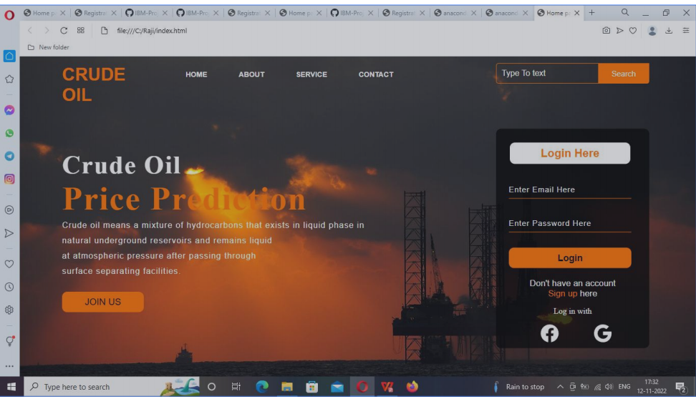

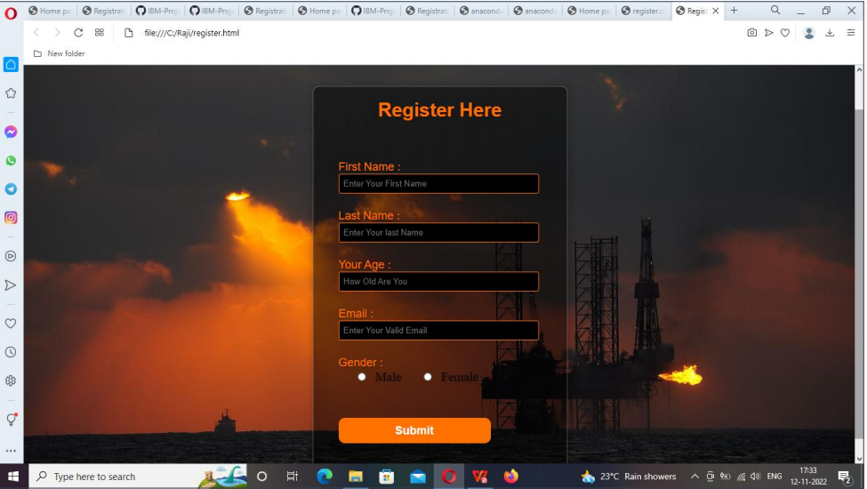

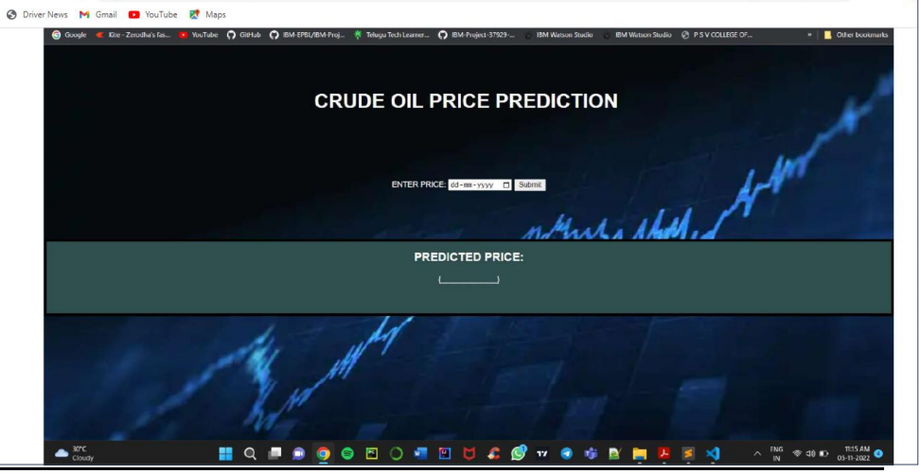

**PROJECT DEMO LINk:**

**https://drive.google.com/file/d/1ERvurcaFkNyJhMZCskF_gQm9fW02b9Bz/view?usp=share_link**